**AgroMate-a self-regulating Iot device**

**A Minor Project II Report**

**Submitted in Partial fulfillment for the award of**

**Bachelor of Technology in CSE-IOT**

Submitted to

**RAJIV GANDHI PROUDYOGIKI VISHWAVIDYALAYA**

**BHOPAL (M.P)**



**MINOR PROJECT REPORT**

Submitted by

Md. Faiz Naushad [0103IS201031]

Nivedit Tiwari [0103IS201037]

Tanishka Gupta [0103IS201058]

|  |  |
| --- | --- |
|  |  |

Under the supervision of

Dr. Sadhana K. Mishra

Head of Department (CSE)









LAKSHMI NARAIN COLLEGE OF TECHNOLOGY, BHOPAL

**DEPARTMENT OF CSE-IOT**

### CERTIFICATE

This is to certify that the work embodied in this project work entitled **“Agromate- a**

**self-regulating Iot Device”** has been satisfactorily completed by the **Md. Faiz Naushad** (0103IS201031), **Nivedit Tiwari** (0103IS201037), **Tanishka Gupta**(0103IS201058). It is a bona fide piece of work, carried out under the guidance in **Department of CSE- IOT**, **Lakshmi Narain College of Technology, Bhopal** for the partial fulfillment of the **Bachelor of Technology** during the academic year 2022-23.

|  |  |
| --- | --- |
| Reviewed By: | Approved By: |
| Dr. Sadhana K. Mishra | Dr. Vivek Richhariya |
| Assistant Prof. | Prof. & Head |
| {Guide} | Department of CSE-IOT |



LAKSHMI NARAIN COLLEGE OF TECHNOLOGY, BHOPAL

**DEPARTMENT OF CSE-IOT**

**Acknowledgement**

We express our deep sense of gratitude to Prof. Dr. Sadhana K. Mishra department of CSE-IOT L.N.C.T., Bhopal, whose kindness valuable guidance and timely help encouraged me to complete this project.

A special thank goes to Dr. Vivek Richhariya (HOD) who helped me in completing this project work. He exchanged his interesting ideas & thoughts which made this project work successful.

We would also thank our institution and all the faculty members without whom this project work would have been a distant reality.

Md. Faiz Naushad [0103IS201031]

Nivedit Tiwari [0103IS201037]

Tanishka Gupta [0103IS201058]

|  |  |  |
| --- | --- | --- |
| SR No. | TOPICS | PAGES |
| 1. | Problem Domain. | 1-2 |
| 2. | Literature Review. |  |
| 3. | Major Objective and Scope of Project. | 3-4 |
| 4. | Problem Analysis and Requirement Specification. | 5-6 |
| 5. | Detailed Design. | 7-11 |
| 6. | Software Platform Environment. | 12-19 |
| 7. | Snapshots of Input and Output. | 20 |
| 8. | Coding. | 21-25 |
| 9. | Project Limitation and Future Scope. | 26-27 |
| 10. | References. | 28 |

Chapter One: Problem Domain

India’s history talks right about its agricultural efficiency, excellent climatic conditions, and natural-resource availability. India (that utilizes extensive parts of its land for cultivation of wheat, rice, cotton) is also a leading producer of spices, pulses, and milk in the international market.

A few decades ago, the agriculture sector added 75% to India’s GDP, which has reduced to 14% (the current). However, India was the second-largest producer ($ 367 billion) after China ($ 1,005 billion) among four more countries that held 42% of the global agricultural output – $ 4,771 billion, According to the World Factbook 2014 of the CIA.

As we are seeing the uneven climate conditions, Farmers face various challenges, including:

* **Climate change**: Changing weather patterns, unpredictable rainfall, and extreme weather events such as droughts, floods, and hurricanes can all affect crop yields, leading to crop failures and financial losses.
* **Market volatility:** Farmers are subject to fluctuations in market prices for their crops and livestock. These prices are influenced by global supply and demand, government policies, and other factors that are beyond the control of individual farmers.
* **Access to land and credit**: Many farmers struggle to secure affordable land and credit, which can hinder their ability to invest in their operations and expand their businesses.
* **Labor shortages**: In many parts of the world, farmers face labor shortages due to aging populations, urbanization, and migration to urban areas. This can make it difficult to find skilled workers to help with planting, harvesting, and other tasks.
* **Pests and diseases:** Crops and livestock can be vulnerable to a range of pests and diseases that can affect yield and quality. Managing these threats can be time-consuming and costly.
* **Soil degradation:** Continuous farming can cause soil degradation due to the depletion of nutrients and erosion, which can decrease crop yields and increase production costs.
* **Water scarcity:** Lack of access to adequate water for irrigation and other agricultural practices can limit crop production, especially in areas with water scarcity.

Polyhouse farming while can be looked over as very advantageous at first but when observed closely it is also shrouded by many flaws such as:

* Farmers have slight control over airflow and temperature in naturally ventilated polyhouses unlike artificial ones; this could limit their choice of products to ones that suit the climate.
* Naturally Ventilated Polyhouses have to be unnecessarily taller than those with fan and pad, leading to wastage in metal costs and labor charges during the construction phase.
* In polyhouse, low-quality films cause easy to wear and tear in heavy rains, making crops vulnerable.
* Irrigation can sometimes be challenging as just one type of irrigation in the polyhouse may not be appropriate for crop types and hence needs to manage efficiently. The farming and maintenance cost of the polyhouse is rather high if mishandled and proper care is not taken.
* Increasing temperatures during summer can sometimes damage the cladding of polyhouse farming. After spraying the fertilizers, no one should enter the polyhouse farm for a few hours due to a decrease in the level of oxygen and fresh air.

Thus, with these flaws in mind our project code named AgroMate tries to solve most of the problems associated with polyhouse forming while we try to make our solution more accessible and affordable so that concept of Polyhouse farming can grow at a rapid pace leading to more innovation in the field making the work of farmers much easier.

Chapter Two: Literature Review

Automated poly-house farming is a relatively new technique of agriculture that has gained popularity in recent years. It involves the use of a controlled environment to grow crops in a closed space using sensors to monitor various factors that affect plant growth. These factors include soil moisture, temperature, humidity, UV, and others. This literature review will focus on the various aspects of automated poly-house farming and the role of sensors in its implementation.

One of the major advantages of automated poly-house farming is the ability to grow crops all year round, regardless of the weather conditions. The controlled environment of a poly-house allows for optimal growth conditions, resulting in higher yields and better-quality produce. This is particularly beneficial for farmers in areas where the climate is unfavourable for crop growth, such as in arid regions or areas prone to extreme weather conditions.

The use of sensors is critical to the success of automated poly-house farming. Soil moisture sensors, for instance, allow farmers to monitor the moisture levels in the soil, ensuring that crops receive adequate water. This is particularly important in areas where water is scarce, as it allows farmers to conserve water and use it more efficiently. Similarly, temperature and humidity sensors help farmers maintain optimal growing conditions for their crops, which can result in faster growth and higher yields.

UV sensors are also important in automated poly-house farming as they help farmers monitor the UV levels inside the poly-house. High UV levels can damage plants, while low UV levels can hinder their growth. By monitoring UV levels, farmers can adjust the lighting inside the poly-house to ensure that their crops receive the optimal amount of UV radiation.

In addition to the benefits mentioned above, automated poly-house farming has other advantages, such as reduced pesticide use and lower water consumption. By using a closed environment, farmers can reduce the need for pesticides, as pests and diseases are less likely to enter the poly-house. Similarly, the controlled environment allows for more efficient use of water, as water is recycled and reused within the poly-house.

In conclusion, automated poly-house farming is a promising technique that has the potential to revolutionize agriculture. By using sensors to monitor various factors that affect plant growth, farmers can optimize growing conditions, resulting in higher yields and better-quality produce. With further research and development, automated poly-house farming could become a viable alternative to traditional farming methods, particularly in areas where the climate is unfavourable for crop growth.

Due to our insufficient experience, we have had to a lot of research papers in the field of agriculture from various websites like krishijagran.com, agrifarming.in, researchgate.net and reports from the horticulture department of the state of Telangana and Madhya Pradesh. Each website and report broadened our view on the topic of polyhouse farming of various agricultural commodities like flowers, fruits, vegetables, medicinal herbs etc.

Chapter Three: Major Objective & Scope of the Project.

To Overcome with the problems stated above, may farmers have shifted to modern farming technique. Modern framing techniques such as Greenhouse farming, precision Agriculture, Conservation tillage, Crop Rotation and many more… We come with the idea of automated polyhouse farming.

So, Basically, Polyhouse farming, also known as greenhouse farming, is a type of controlled environment agriculture (CEA) that involves growing crops in a covered structure made of polyethylene, polycarbonate, or glass.

The structure is designed to provide a controlled environment that is optimal for plant growth by regulating temperature, humidity, light, and water. Polyhouses can vary in size from small structures used by hobbyists or home gardeners to large commercial structures that span several acres. They can be used to grow a wide variety of crops, including vegetables, fruits, flowers, and herbs.

Polyhouse farming has several advantages over conventional open-field farming. It allows for year-round cultivation of crops, protects crops from pests and diseases, reduces water usage, and enables farmers to grow crops that would not be able to survive in their natural environment.

Overall, polyhouse farming is a useful tool for farmers looking to improve their yields and reduce their costs by providing a controlled environment that is optimal for plant growth.

We have developed the fully automated IoT Device which will regulate the whole temperature and humidity condition inside the polyhouse as we know that if the humidity increases there are high chances of crop failure.

We are also focusing on the agenda of save water, for this we are using the approach of drip irrigation. For prevention of pests, we will install the sprinklers for pesticides.

“In order to meet the growing demand for food in a sustainable way, farmers are turning to innovative techniques such as polyhouse farming.”

In a polyhouse we are going to automate and monitor all the weather conditions and suitable environment for the crops covered with a transparent material like polyethylene or glass.

Our approach is basically based on automating the temperature and humidity inside the polyhouse without any manpower needed.

Farmers just need to set the type of crop he's growing and by that data our IoT device will automate the temperature and humidity conditions .

Our System works on drip irrigation which saves a lot of water and water reaches to each respective plants drop-by-drop.

**Working of our IoT Based device:**

Our project utilizes an array of components ranging from sensors to water pumps, microcontrollers and etc. A basic working of our project is given below:

Temperature and humidity sensors: Temperature and Humidity sensor (DHT11) is placed inside the polyhouse with the intent of monitoring internal conditions and relaying it to the microcontroller. These sensors transmit data to a microcontroller and the microcontroller can transmit this data to cloud using the ESP8266 Wi-Fi module. In our project we primarily use the observations from these sensors to manipulate the fans with the purpose of improving ventilation to deal with excess humidity and water-cooled mesh layers can also be used for cooling the air that maybe thrown into the polyhouse through the fans with the purpose of regulating the temperature.

Soil moisture sensors: Soil moisture sensors are placed at different locations in the soil to measure the soil's moisture content. This information helps us regulate irrigation and prevent overwatering or underwatering. We have hooked up a relay and water pump mechanism which is used for the purpose of drip irrigation further enhancing our ability to control the amount of water given to the plants.

UV sensors: In our project we make use of UV Sensor (GUVA S12SD) to measure amount of UV radiation inside the polyhouse. This information helps us optimize plant growth and productivity by adjusting the UV radiation levels because UV rays also act as a deterrent to harmful microorganisms that develop overtime and lead to diseases in plants affecting the overall yield.

Security system: By placing proximity detection sensors around the polyhouse's perimeter, we can detect any suspicious intruders who are trying to approach the polyhouse with malicious intent. These sensors transmit data to a microcontroller or a computer, which can trigger an alarm system to alert you about the potential intruder or even send a SMS alert using the GSM module (SIM900A GSM Module) .

Microcontroller/Computer: Microcontrollers can be either an Arduino or a RaspberryPi depending on the scale of the automation required in the polyhouse. If added calculations and decision making is required mostly in the case of Crop Growth Analysis then the data from the microcontroller can even be off sourced to cloud using ESP8266 Wi-Fi module. The data collected in cloud (mostly Thingspeak Cloud) could then be analysed and necessary changes can be made regarding the drip irrigation, fan ventilation etc. We can use this data to regulate the environment inside the polyhouse, such as adjusting temperature and humidity levels, irrigation, and UV radiation levels. We can also program the microcontroller locally to trigger the alarm system when the proximity detection sensors detect an intruder.

**Chapter Four: Problem Analysis & Requirement Specification.**

Polyhouse farming can provide a controlled environment that helps overcome several problems faced by traditional open-field farming. However, traditional polyhouse farming can also have its own set of problems. Here are some of the problems faced by traditional polyhouse farming:

**High initial investment:** The construction and set-up costs of a traditional polyhouse can be high, making it difficult for small-scale farmers to adopt this method of farming.

**High energy costs:** Traditional polyhouses require energy to maintain the controlled environment, which can lead to high energy costs. This can be particularly challenging in areas where electricity is unreliable or expensive.

**Maintenance costs:** Polyhouses require regular maintenance to ensure that the controlled environment is working optimally. This can include cleaning the structure, checking and repairing equipment, and replacing worn-out parts.

**Pest and disease management:** While polyhouses can help protect crops from pests and diseases, they can also create an environment that is conducive to the growth of certain pests and diseases. This requires careful monitoring and management to prevent outbreaks.

**Difficulty in managing temperature and humidity:** Traditional polyhouses can be difficult to manage in extreme weather conditions, such as heat waves or cold snaps. Maintaining optimal temperature and humidity levels can be challenging and may require additional equipment or resources.

Based on Our Problem analysis, we identified the software and hardware requirements needed for this project.

For this project we required Software known as Arduino IDE for coding of sensor’s part and ThingSpeak Cloud For connectivity with the cloud .

Hardware components involves:

* Arduino Uno Board
* ESP8266 Wi-Fi Module
* AE GSM Modem
* Solar Panels (Future Advancements)

Various Sensors:

* DHT11 Temperature and Humidity Sensor
* GUVA S12SD UV Sensor
* LM393 chip-based Soil Moisture Sensor
* NPK Sensor (Can be used for future upgraded device

Additional Hardware devices needed for this project are:

* Fans
* Water Sprinklers
* Water Pump

Sensors play a pivotal role in the internet of things (IoT). They make it possible to create an ecosystem for collecting and processing data about a specific environment so it can be monitored, managed and controlled more easily and efficiently. IoT sensors are used in homes, out in the field, in automobiles, on airplanes, in industrial settings and in other environments. Sensors bridge the gap between the physical world and logical world, acting as the eyes and ears for a computing infrastructure that analyzes and acts upon the data collected from the sensors.

We choose to use the Arduino Uno Rev 3 microcontroller because it is easy to learn and use as the Arduino IDE is based on C++ programming language. Arduino boards provide higher versatility as Arduino comes with a wide variety of boards for the purpose of IoT development. Arduino boards are widely supported with a very large community and wide plethora of tutorial videos to help with the basics. Arduino boards are highly cost effective as they are very widely available and non-genuine first copy boards are available with relative ease. Arduino Software and Hardware are opensource and thus making it very easy to modify the parts and sensors.

Even though Arduino supports a maximum of 5V output through ports at maximum it is not enough to run the fans or water pumps at their highest capacity thus they would be undervolted at best. So in order to utilize the additional hardware devices we would need to power them through external means.

**Chapter Five: Detailed Design**

A polyhouse, also known as a greenhouse, is a type of structure used for growing plants that require controlled climatic conditions. It is made of a frame of steel or aluminum covered with a transparent material, usually polyethylene plastic, which allows sunlight to enter and trap heat inside, creating a warm and humid environment for plants.

Polyhouses are used to protect plants from harsh weather conditions such as heavy rain, extreme heat or cold, wind, and pests. They are commonly used in agriculture for growing crops like fruits, vegetables, flowers, and ornamental plants, especially in areas with unfavorable climate conditions. By controlling temperature, humidity, and light levels, farmers can extend the growing season and increase the yield and quality of their crops.

**Features And Benefits:**

**Increased Yield:** An IoT-based polyhouse farm with solar power and drip irrigation helps increase yield by providing the necessary conditions required for plants to thrive. With real-time monitoring, sensors can be used to monitor soil moisture levels, temperature, and other parameters, which ensures that plants receive the right amount of water, fertilizer, and sunlight.

**Energy Efficiency**: Utilizing solar power for farming not only reduces the farm's carbon footprint and greenhouse gas emissions, but it also reduces energy costs by reducing reliance on grid power.

**Water Conservation:** Drip irrigation is a water conservation method that delivers water to the plant's roots precisely in the required amount, reducing water wastage. With IoT, farmers can schedule watering based on local weather forecasts and soil moisture sensors, which reduces the risk of overwatering.

**Lower Labor Costs:** With automated systems, farmers can minimize labor costs since there is no need for manual monitoring and watering of the plants, which leads to increased productivity.

**Improved Quality of Produce:** With precise control over the growth environment, farmers can produce crops that are more consistent in size, shape, and quality.

**Disease Prevention:** Automatic IoT-based monitoring systems can help detect plant diseases and infestations quickly, enabling farmers to take corrective measures immediately, reducing crop loss.

**Dehumidifying:** The biggest drawback of traditional polyhouse was Humidity which leads to development of mites, thrips, and fungal infection which highly affect the productivity of the crops, in this IoT based polyhouse it will automatically Dehumidify the excess Humidity in Polyhouse leading better and efficient growth of the crop.

**Design of Polyhouse farming:**

The design of a polyhouse (or greenhouse) can vary depending on the specific needs and requirements of the plants being grown, the location, and the budget. However, here are some general elements that are commonly included in a polyhouse design:

1. **Frame:** The frame is typically made of steel or aluminium and provides the structure for the polyhouse. It should be strong enough to support the covering material and any equipment or accessories that may be installed.
2. **Covering material:** The covering material is usually made of polyethylene plastic, which allows sunlight to enter while protecting the plants from the elements. The thickness and quality of the plastic should be chosen based on the climate and weather conditions of the location.
3. **Ventilation:** Proper ventilation is important to prevent the build-up of heat and humidity inside the polyhouse. This can be achieved through vents and fans that allow for air circulation and exchange.
4. **Heating and cooling:** Depending on the location and climate, additional heating or cooling systems may be needed to maintain the desired temperature inside the polyhouse. This can be done through the use of heaters, air conditioning units, or evaporative cooling systems.
5. **Irrigation**: An irrigation system is necessary to provide the plants with the necessary amount of water. This can be done through a drip irrigation system or a misting system.
6. **Lighting**: Artificial lighting may be needed in areas with low light levels or during the winter months when daylight hours are shorter. This can be achieved through the use of LED grow lights.
7. **Automation:** Various systems such as temperature sensors, humidity sensors, and automatic irrigation systems can be added to automate and optimize the growing process.

Overall, the design of a polyhouse should aim to create a controlled environment that meets the specific needs of the plants being grown while optimizing efficiency and productivity.

For this model we used CPU fans to demonstrate the ventilation inside the polyhouse and pump to demonstrate the drip irrigation.

**Circuit Diagram:**

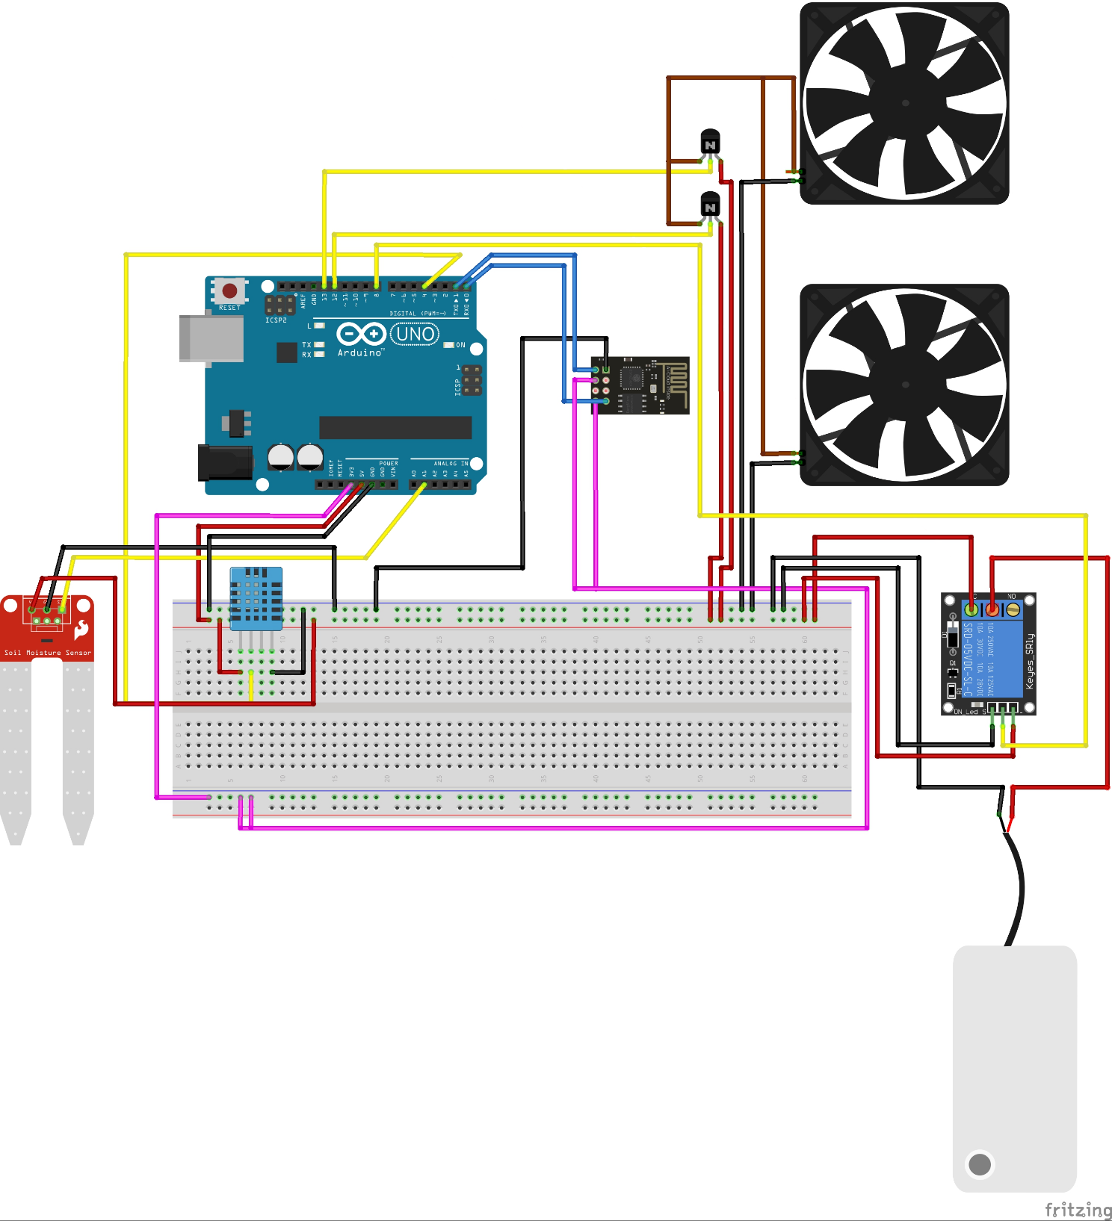

**Data Flow Diagram:**

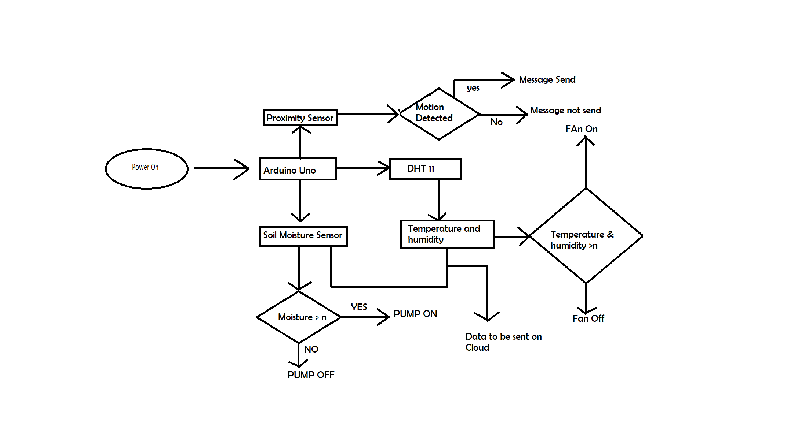

**Top of Form**

**Chapter Six: Hardware & Software Platform Environment**

For this Project we have used combination of both Hardware and software components:

So, Our Project is totally based on IoT.

IoT stands for the Internet of Things, which refers to a network of physical devices that are connected to the internet and can communicate with each other and with other systems. These devices can range from simple sensors to complex machines and can be embedded in various objects such as appliances, vehicles, and buildings.

The concept of IoT involves using sensors, software, and network connectivity to enable communication and data exchange between devices, and to collect and analyze data about the physical world. This data can then be used to automate processes, improve efficiency, and inform decision-making.

IoT is a combination both hardware and software.

Various Sensors Used are:

A sensor is a device that detects and responds to some type of input from the physical environment. The input can be light, heat, motion, moisture, pressure or any number of other environmental phenomena. The output is generally a signal that is converted to a human-readable display at the sensor location or transmitted electronically over a network for reading or further processing.

1. DHT11(Temperature and humidity Sensor)
2. GUVA S12SD UV Sensor
3. LM393 chip-based soil moisture Sensor.
4. NPK Sensor (Future Advancements)
5. **DHT11(Temperature and Humidity Sensor)**

The DHT11 sensor is a low-cost, digital temperature and humidity sensor that is commonly used in various applications such as weather stations, HVAC systems, and other projects that require environmental monitoring. It is a basic sensor that can provide accurate readings of temperature and humidity in a given area.

The DHT11 sensor uses a capacitive humidity sensor and a thermistor to measure the temperature and humidity of the surrounding environment. The sensor has a small plastic body with four pins that can be easily connected to a microcontroller or other electronic device.

The DHT11 sensor is capable of measuring temperature between 0°C to 50°C with an accuracy of ±2°C and relative humidity between 20% to 90% with an accuracy of ±5%. It has a low power consumption and can be powered with a 3 to 5V DC supply.

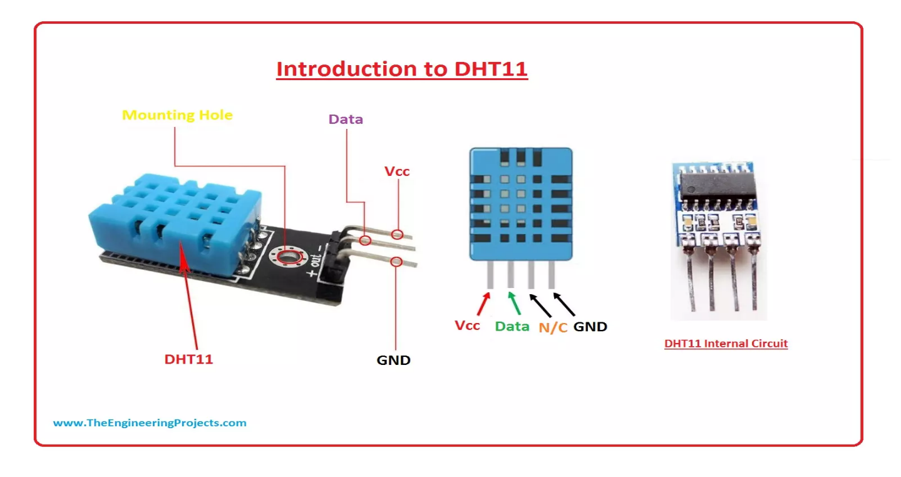

1. **GUVA S12SD UV Sensor**

The GUVA S12SD UV sensor is a device that is used to detect ultraviolet (UV) radiation in the environment. It is a compact, low-cost sensor that can be easily integrated into various applications such as UV index monitoring, skin protection, and air quality monitoring. The GUVA S12SD UV sensor is based on a photodiode that detects UV radiation in the wavelength range of 240nm to 370nm. The sensor provides a voltage output that is proportional to the intensity of the UV radiation detected. The sensor has a response time of less than 0.1 seconds and can operate in a wide temperature range of -20°C to 85°C.

The GUVA S12SD UV sensor is commonly used in applications such as:

1. UV Index monitoring: The sensor can be used to measure the UV index in a given area, which is an important factor in determining the risk of sunburn and skin damage.
2. 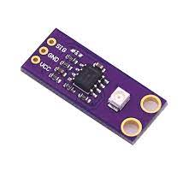Skin protection: The sensor can be used to monitor the UV radiation levels and provide alerts to users to take appropriate measures to protect their skin from the harmful effects of UV radiation.
3. Air quality monitoring: The sensor can be used to detect UV radiation levels in the atmosphere, which can be used as an indicator of air pollution levels.
4. **LM393 chip-based soil moisture Sensor.**

The LM393 chip-based soil moisture sensor is a device that is used to measure the moisture content of soil. It is a low-cost and easy-to-use sensor that can be integrated into various applications such as irrigation systems, gardening, and agriculture.

The LM393 chip-based soil moisture sensor consists of two probes that are inserted into the soil. The sensor uses a LM393 comparator chip to detect the resistance between the two probes, which is proportional to the moisture content of the soil. The sensor provides a digital output that can be read by a microcontroller or other electronic device.

The LM393 chip-based soil moisture sensor has several advantages over other soil moisture sensors. It is low cost, easy to use, and has a long service life. It can be used with a wide range of microcontrollers and other electronic devices, making it a versatile option for various projects.

The LM393 chip-based soil moisture sensor is commonly used in applications such as:

1. Irrigation systems: The sensor can be used to detect the moisture content of the soil and provide feedback to an irrigation system, helping to ensure that plants receive the appropriate amount of water.
2. Gardening: The sensor can be used to monitor the moisture content of soil in a garden, helping gardeners to optimize watering schedules and improve plant health.
3. 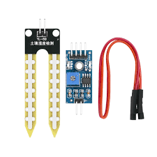Agriculture: The sensor can be used to monitor soil moisture in agricultural fields, helping farmers to optimize irrigation schedules and improve crop yields.
4. **NPK Sensor**

The NPK sensor is a device that is used to measure the concentration of three essential nutrients in soil: nitrogen (N), phosphorus (P), and potassium (K). These nutrients are vital for plant growth and are commonly found in fertilizers.

The NPK sensor typically consists of several probes that are inserted into the soil to measure the nutrient levels. The probes use various technologies such as spectroscopy, electrochemistry, or ion-selective membranes to measure the nutrient concentrations in the soil. The sensor provides a digital output that can be read by a microcontroller or other electronic device.

The NPK sensor is commonly used in precision agriculture to optimize fertilizer use and improve crop yields. By accurately measuring the nutrient levels in soil, farmers can tailor their fertilizer applications to the specific needs of their crops, helping to reduce costs and increase yields. The sensor can also be used to monitor nutrient levels in greenhouse and hydroponic systems.

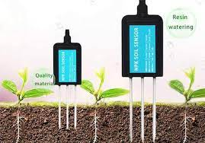

**Arduino Uno:**

Arduino Uno is a popular microcontroller board based on the ATmega328P microcontroller, developed by Arduino. It is a simple and user-friendly platform for creating electronic projects with a wide range of applications, from robotics and automation to home automation and IoT (Internet of Things) devices.

The Arduino Uno board has several digital input/output pins that can be used to connect sensors, actuators, and other electronic devices. It also has analogy input pins for measuring signals such as temperature and light intensity, as well as PWM (Pulse Width Modulation) pins for controlling devices such as LEDs and motors. The board is programmable using the Arduino programming language, which is based on C and C++.

The Arduino Uno board is designed to be easy to use, even for beginners with little or no experience in electronics or programming. The board can be powered by a USB cable or an external power source, and it can be programmed using the Arduino IDE (Integrated Development Environment), which is a free software tool that provides an easy-to-use interface for writing, compiling, and uploading code to the board.

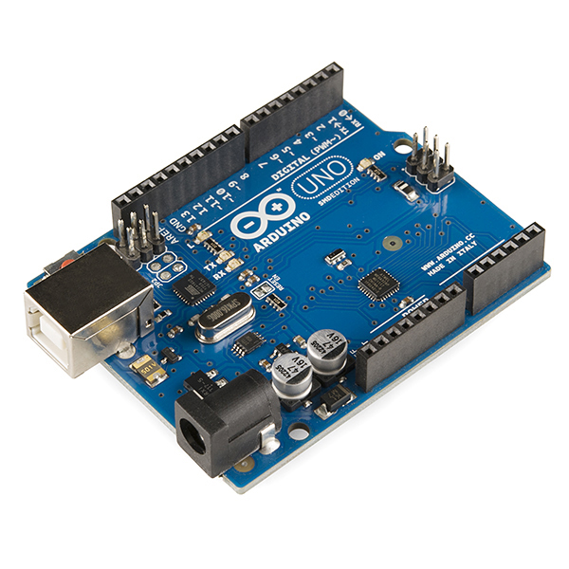

**ThingSpeak Cloud**

ThingSpeak is an Internet of Things (IoT) analytics platform that allows users to collect, store, and analyse data from various IoT devices and sensors. ThingSpeak provides a cloud-based service that enables users to store and retrieve data in real-time, as well as perform analytics and visualize the data through charts, graphs, and maps.

The platform offers a wide range of features, including:

1. Data storage and retrieval: ThingSpeak provides a cloud-based data storage service that allows users to store and retrieve data from their IoT devices in real-time.
2. Data visualization: ThingSpeak offers a range of visualization tools, including charts, graphs, and maps, that enable users to analyse and interpret their IoT data.
3. Customizable dashboards: ThingSpeak allows users to create custom dashboards that display their IoT data in real-time, providing a visual representation of the data and enabling users to monitor their devices and systems.
4. Analytics: ThingSpeak provides analytics tools that enable users to perform complex data analysis on their IoT data, including statistical analysis, machine learning, and predictive modelling.
5. Integrations: ThingSpeak can be integrated with a wide range of IoT devices, sensors, and platforms, making it a versatile tool for IoT applications.

Overall, ThingSpeak is a powerful IoT analytics platform that offers a wide range of features and capabilities for collecting, storing, analysing, and visualizing data from IoT devices and sensors. Its cloud-based service and easy-to-use interface make it a popular choice for IoT developers and enthusiasts.

**Top of Form**

1. 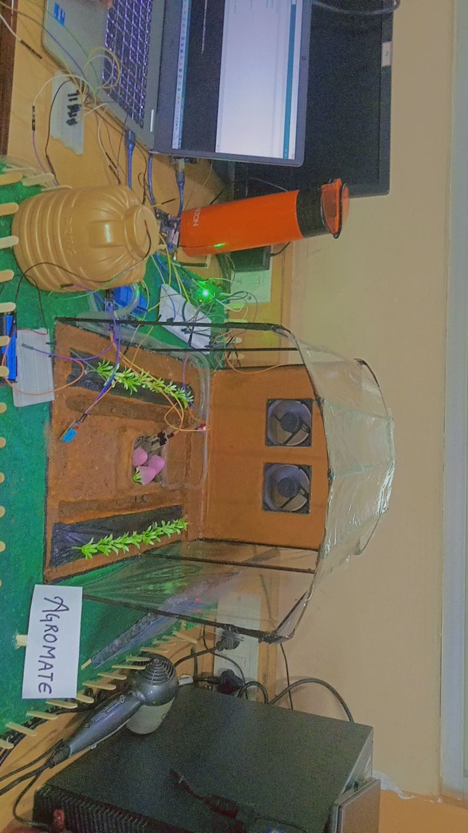**Snapshots of Input and Output.**

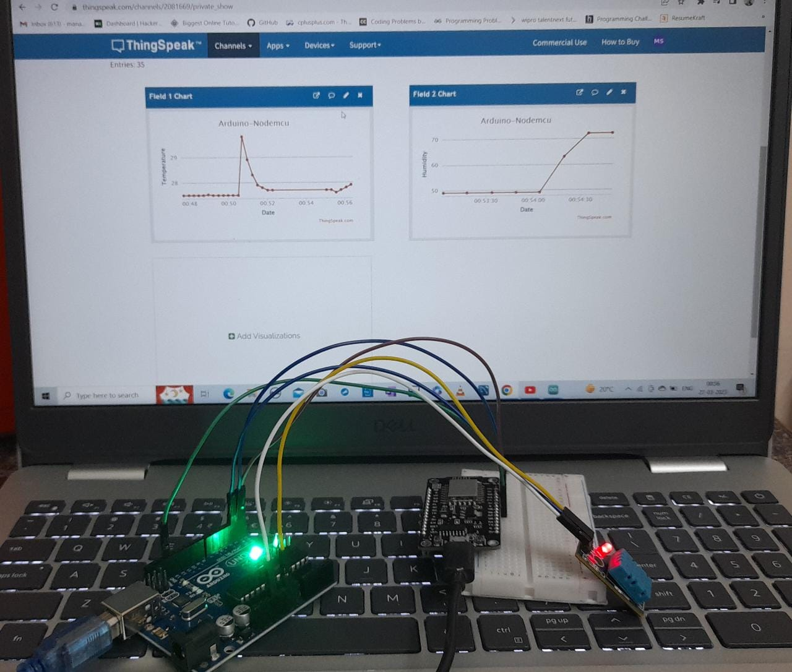

1. **Coding:**

**Code for DHT11 (Temperature and Humidity Sensor with integration to the fans):**

#include "DHT.h"

#define DHTPIN 8 // what pin we're connected to

#define DHTTYPE DHT11 // DHT 11

#define pwm 9

int m_s = A0;

DHT dht(DHTPIN, DHTTYPE);

void setup() {

analogWrite(pwm, 255);

Serial.begin(9600);

dht.begin();

}

void loop() {

// Wait a few seconds between measurements.

delay(2000);

// Reading temperature or humidity takes about 250 milliseconds!

// Sensor readings may also be up to 2 seconds 'old' (its a very slow sensor)

float h = dht.readHumidity();

// Read temperature as Celsius

float t = dht.readTemperature();

// Read temperature as Fahrenheit

float f = dht.readTemperature(true);

// Check if any reads failed and exit early (to try again).

if (isnan(h) || isnan(t) || isnan(f)) {

Serial.println("Failed to read from DHT sensor!");

return;

}

if(t <20)

{

digitalWrite(pwm, 255);

delay(100);

}

else if(t>=20 && t<30)

{

digitalWrite(pwm, 135);

delay(100);

}

else

{

digitalWrite(pwm, 0);

delay(100);

}

Serial.print("Temperature: ");

Serial.println(t);

Serial.print("Humidty: ");

Serial.println(h);

}

**Code for Soil Moisture Sensor (Soil Moisture Sensor and Relay attached with Water Pump):**

int m_s = A0;

void setup(){

pinMode(13,OUTPUT);

Serial.begin(9600);

dht.begin();

}

void loop(){

//Wait a few seconds for measurements.

delay(2000);

int Moisture = 0;

Moisture = analogRead(m_s);

Serial.print(“Soil Moisture Level: “);

Serial.println(Moisture);

Serial.println();

if(Moisture > 300){

analogWrite(13,HIGH);

}

else{

analogWrite(13,LOW);

}

}

**Code for Soil Moisture Sensor (Soil Moisture Sensor and Relay attached with Water Pump):**

int UVOUT = A0; //Output from the sensor

int REF_3V3 = A1; //3.3V power on the Arduino board

void setup()

{

Serial.begin(9600);

pinMode(UVOUT, INPUT);

pinMode(REF_3V3, INPUT);

Serial.println("ML8511 example");

}

void loop()

{

int uvLevel = averageAnalogRead(UVOUT);

int refLevel = averageAnalogRead(REF_3V3);

//Use the 3.3V power pin as a reference to get a very accurate output value

float outputVoltage = 3.3 / refLevel * uvLevel;

float uvIntensity = mapfloat(outputVoltage, 0.99, 2.8, 0.0, 15.0);

Serial.print("output: ");

Serial.print(refLevel);

Serial.print("ML8511 output: ");

Serial.print(uvLevel);

Serial.print(" / ML8511 voltage: ");

Serial.print(outputVoltage);

Serial.print(" / UV Intensity (mW/cm^2): ");

Serial.print(uvIntensity);

Serial.println();

delay(100);

}

//Takes an average of readings on a given pin

//Returns the average

int averageAnalogRead(int pinToRead)

{

byte numberOfReadings = 8;

unsigned int runningValue = 0;

for(int x = 0 ; x < numberOfReadings ; x++)

runningValue += analogRead(pinToRead);

runningValue /= numberOfReadings;

return(runningValue);

}

float mapfloat(float x, float in_min, float in_max, float out_min, float out_max)

{

return (x - in_min) * (out_max - out_min) / (in_max - in_min) + out_min;

}

**Thingspeak Data Visualization using Node mcu**

#include<SoftwareSerial.h>

#include<WiFiClient.h>

#include<ESP8266HTTPClient.h>

#include<ThingSpeak.h>

#include <ESP8266WiFi.h>

SoftwareSerial ms(D1,D2);

// String URL = "https://api.thingspeak.com/update?api_key=ZVS472KDKZJEM6AB&field1=0";

WiFiClient client; // Here the client is NodeMCU and Thingspeak will act as a server.

long myChannelNumber = 2081669;

const char myWriteAPIKey[] = "ZVS472KDKZJEM6AB";

void setup() {

// put your setup code here, to run once:

Serial.begin(115200);

ms.begin(9600);

//WiFi.disconnect();

delay(2000);

Serial.print("Start connection");

WiFi.begin("Restricted","12345678");

while(WiFi.status() != WL_CONNECTED)

{

delay(200);

Serial.println("...");

}

Serial.println("Connected");

ThingSpeak.begin(client);

}

void loop() {

// put your main code here, to run repeatedly:

if(ms.available()>0)

{

String data = ms.readStringUntil('\n');

Serial.println(data);

int comma = data.indexOf(',');

// int dash = data.indexOf('-');

if(comma != -1)

{

float t = data.substring(0,comma).toFloat();

float h = data.substring(comma+1).toFloat();

// float m = data.substring(dash+1).toFloat();

Serial.println(t);

Serial.println(h);

//Serial.println(m);

ThingSpeak.writeField(myChannelNumber, 1, t, myWriteAPIKey);

ThingSpeak.writeField(myChannelNumber, 2, h, myWriteAPIKey);

//ThingSpeak.writeField(myChannelNumber, 3, m, myWriteAPIKey);

}

}

}

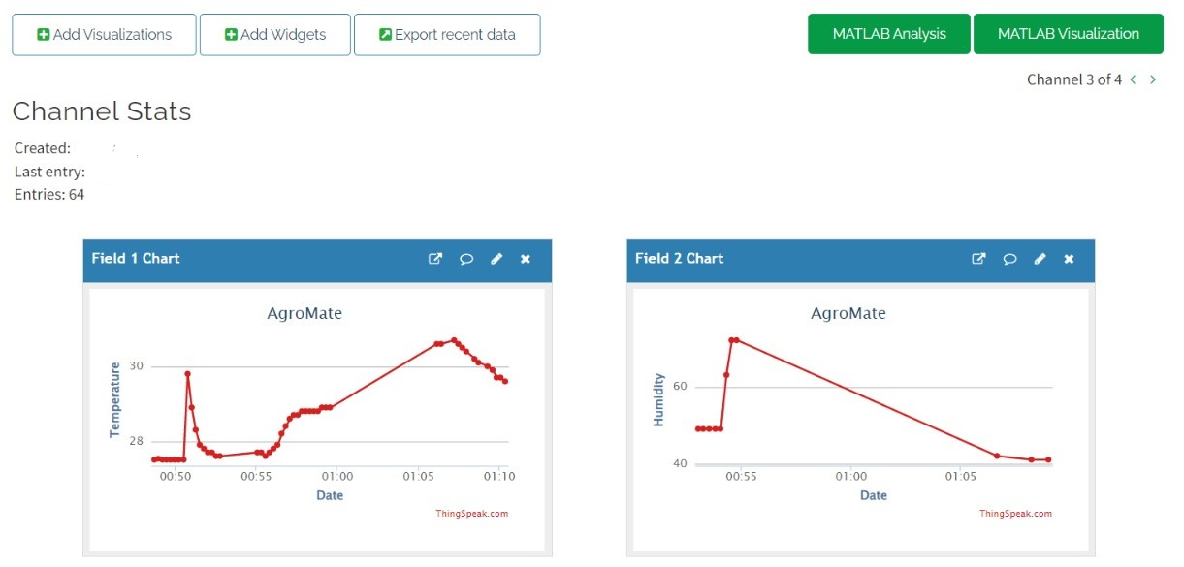

**8.Project Limitation & Future Scope**

As with any project, there are limitations to the implementation of an automated poly-house farming system. Some of the limitations that could be encountered in your project are:

* High Initial Investment: Setting up an automated poly-house farming system requires a significant initial investment in equipment and infrastructure, such as sensors, controllers, and lighting systems. This may be a limitation for farmers who do not have the financial resources to invest in such a system.
* Technical Expertise: Implementing an automated poly-house farming system requires technical expertise in areas such as electronics, software programming, and agricultural science. Farmers who do not have this expertise may find it challenging to set up and maintain the system.
* Maintenance and Repair: Automated poly-house farming systems require regular maintenance and repair to ensure that they function correctly. This may require additional resources and time, which could be a limitation for farmers who have limited resources.
* Energy Consumption: Automated poly-house farming systems require a significant amount of energy to maintain optimal growing conditions, such as temperature and lighting. This may result in higher energy bills, which could be a limitation for farmers who are already operating on a tight budget.
* Crop Selection: Not all crops may be suitable for automated poly-house farming. Some crops may require specific growing conditions that are difficult to replicate in a closed environment, limiting the variety of crops that can be grown in the system.

It is important to consider these limitations when planning and implementing an automated poly-house farming system, as they could impact the success of the project. By acknowledging these limitations, we can develop strategies to address them and ensure the sustainability and effectiveness of our system.

**Future Scope:**

Automated poly-house farming is a relatively new technology that has significant potential for the future of agriculture. As technology continues to advance, the future scope of your project may include:

* Integration of Artificial Intelligence (AI): AI can be used to analyse data collected by sensors in automated poly-house farming systems. This can help farmers make more informed decisions regarding crop management and resource allocation, leading to higher yields and more efficient use of resources.
* Use of Drones: Drones can be used to monitor crop growth and detect potential issues, such as pest infestations or disease outbreaks. This can help farmers take corrective actions before the issues become widespread and impact crop yields.
* Expansion of Crop Selection: As technology continues to advance, it may become possible to grow a wider variety of crops in automated poly-house farming systems. This could lead to increased crop diversity and a more sustainable food supply.
* Implementation of Sustainable Practices: Automated poly-house farming systems can be designed to incorporate sustainable practices, such as the use of renewable energy sources, water conservation, and waste reduction. This can help minimize the environmental impact of agriculture and ensure the long-term sustainability of food production.
* Implementation in Urban Agriculture: Automated poly-house farming systems can be scaled down and implemented in urban areas, allowing for locally grown produce and reducing the carbon footprint associated with food transportation. This can help increase access to fresh, healthy produce in urban areas and promote sustainable food systems.

These are just a few potential future scopes for our project. As technology continues to advance, the possibilities for automated poly-house farming systems are endless, and our project could play a vital role in shaping the future of agriculture.

**9.References**

Some articles we referred for our project:

* Chandra, S., & Singh, A. (2019). Smart polyhouse: An automated greenhouse for effective plant growth. In Proceedings of the 3rd International Conference on Smart Computing and Informatics (pp. 451-462). Springer, Singapore.
* Li, Z., Xiang, L., & Wu, J. (2020). The design and implementation of automatic control system for plant factory based on IoT technology. Journal of Physics: Conference Series, 1528(1), 012034.
* Patel, N., & Patel, V. (2018). Intelligent greenhouse system using IoT. In Proceedings of the 2018 3rd International Conference on Internet of Things: Smart Innovation and Usages (pp. 1-6). IEEE.
* Rizwan, M., & Siddiqui, S. H. (2018). Design and implementation of IoT based automatic polyhouse farming system. In Proceedings of the 2018 2nd International Conference on Computer, Communication, and Signal Processing (pp. 1-5). IEEE.
* Singh, G., Tripathi, S., & Rai, R. K. (2018). An IoT-based smart polyhouse for real-time monitoring of environmental parameters. In Proceedings of the 2018 2nd International Conference on Trends in Electronics and Informatics (pp. 665-669). IEEE.
* Sundaram, S., & Nair, N. (2019). Intelligent greenhouse using Raspberry Pi and Arduino. In Proceedings of the 2019 International Conference on Automation, Computational and Technology Management (pp. 1-6). IEEE.
* Zhang, Y., Zhang, J., Hu, G., & Huang, Y. (2021). Smart agriculture system based on IoT and machine learning. IEEE Internet of Things Journal, 8(5), 3835-3845.
* "Greenhouse Powered by Renewable Energy and IoT Sensors." YouTube, uploaded by Intel Internet of Things, 19 Feb. 2018, <https://www.youtube.com/watch?v=CbZvGM8oPGc>.
* "IoT Based Smart Agriculture using Raspberry Pi and Machine Learning." YouTube, uploaded by EdGate Technologies, 22 Nov. 2020, <https://www.youtube.com/watch?v=2Y-BCR_P6vI>.
* "Robotics for Smart Greenhouse Cultivation." YouTube, uploaded by Euronews Living, 22 Apr. 2021, <https://www.youtube.com/watch?v=pVl61TjT3kw>.
* "Smart Farming with IoT and Cloud Computing." YouTube, uploaded by IBM Watson IoT, 23 May 2017, <https://www.youtube.com/watch?v=62Jc-mF0fWc>.
* "Vertical Farming System using IoT." YouTube, uploaded by Innovate Makers, 28 Aug. 2020, <https://www.youtube.com/watch?v=y6qu5b2OgOc>.